Machine Learning and Advanced Analytics Document
By Keerthana and Team
Legal Disclaimer
This document contains unpublished, confidential and proprietary information of Excelacom Inc. that is protected by copyright and other intellectual property laws.
Excelacom Inc. software and its related documentation are subject to and made available only pursuant to the terms of a license agreement with Excelacom Inc and may be used or copied only in accordance with the terms of that agreement.
Any use, copying, reproduction, alteration, transmission, or translation of these materials, in whole or in part, in any form or by any means, is strictly prohibited without the prior written permission of Excelacom Inc.
If this material is provided with software licensed by Excelacom Inc. the information herein is provided subject to the terms of the warranty provided with the product license. If this material is not provided with licensed software, the information herein is provided "as is" without warranty of any kind. In either case, there are no other warranties, either express or implied, including, but not limited to the implied warranties of merchantability, fitness for a particular purpose, non-infringement, or quality. In no event shall Excelacom Inc. or any of its affiliates be liable for any direct or indirect, special, incidental, consequential, punitive, or exemplary damages arising out of the use or inability to use the materials and/or information contained herein. Some jurisdictions do not allow the exclusion of implied warranties, so the above exclusion may not apply to you.
Excelacom Inc. takes reasonable measures to ensure the quality of the data and other information produced by Excelacom Inc. that is made available herein. However, these materials may contain technical inaccuracies or typographical errors, and are not guaranteed to be error-free. Information may be changed or updated without notice. Excelacom Inc. has no obligation to update the information in this material based on changes to its products or services or those of third parties. Excelacom Inc. may also make improvements or changes to the products or services described in this information at any time without notice.

Table of Contents
1. Machine Learning and Advanced Analytics 6
1.1. Purpose 6
1.2. Scope 6
1.3. Components of Machine Learning and Advanced Analytics 6
2. Design Overview 7
2.1. Process Flow Diagram 7
2.2. Architecture Diagram 8
3. MLAA Workflow 9
3.1. Overview 9
3.2. Data Preparation (Ingestion) 9
3.3. Data Cleansing & Feature Engineering (Quality & Transformation) 9
3.4. Machine Learning (Algorithm Selection & Hyperparameter Tuning) 10
3.5. Model Validation & Summary (Performance Metrics & Reporting) 10
3.6. Production Inference (Batch & Real-time Prediction) 10
3.7. Administration Module (Lifecycle & Governance) 11
4. Functional Description 12
4.1. Data Preparation 12
4.1.1. Connecting 12
4.1.2 Joining and Merging 12
4.1.3 Concatenating 12
4.1.4 Sampling and splitting 12
4.1.5 Database Query 12
4.1.6 Time Series 12
4.2. Data Cleansing and Analysis 12
4.2.1. Data Ingestion 12
4.2.2. Data Preview 12
4.2.3. Data Insights 12
4.2.4. Suspect Data 12
4.2.5. Missing and Invalid Data 12
4.2.6. Numerical Attributes 12
4.2.7. Categorical Attributes 12
4.2.8. Other Attributes 12
4.2.9. Derived Attributes 12
4.2.10. Feature Engineering 12
4.3. Machine Learning 12
4.3.1. Data Ingestion 12
4.3.2. Data Preview 12
4.3.3. Correlation Matrix 12
4.3.4. Supervised Selection 12
4.3.5. Unsupervised Selection 12
4.3.6. Training Configuration 12
4.3.7. View Projects 12
4.4. Batch Prediction 12
4.5. Real Time Prediction 12
4.6. Administration 12
5. Sequence Diagram 12
6. Class Diagram 12
7. State Diagram 12
8. API Specifications 14
8.1 API Listing 14
8.2 loadPage – ML Application Homepage 14
8.2.1 Purpose 14
8.2.1 API URL 14
8.2.3 Request Method 14
8.2.4 API Request Attribute Details 14
8.2.5 API Response Attribute Details 14
8.3 saveFeatureSelection – Stores Significant Attributes 15
8.3.1 Purpose 15
8.3.2 API URL 15
8.3.3 Request Method 15
8.3.4 API Request Attribute Details 15
8.3.5 API Response Attribute Details 15
8.4 getPaginatedModelList – Displays Project List 15
8.4.1 Purpose 15
8.4.2 API URL 15
8.4.3 Request Method 15
8.4.4 API Request Attribute Details 15
8.4.5 API Response Attribute Details 15
8.5 uploadTrainData – Uploads Dataset 16
8.5.1 Purpose 16
8.5.2 API URL 16
8.5.3 Request Method 16
8.5.4 API Request Attribute Details 16
8.5.5 API Response Attribute Details 16
8.6 trainMachineLearning – Initiates Model Training 16
8.6.1 Purpose 16
8.6.2 API URL 16
8.6.3 Request Method 16
8.6.4 API Request Attribute Details 16
8.6.5 API Response Attribute Details 16
8.7 saveAlgorithm– saves the algorithm configuration for training 17
8.7.1 Purpose 17
8.7.2 API URL 17
8.7.3 Request Method 17
8.7.3 API Request Attribute Details 17
8.7.4 API Response Attribute Details 17
8.8 predictionService - Generates Model Predictions 17
8.8.1 Purpose 17
8.8.2 API URL 17
8.8.3 Request Method 17
8.8.4 API Request Attribute Details 17
8.8.5 API Response Attribute Details 17
8.9 saveOutlierRules - Saves Outlier Rules 17
8.9.1 Purpose 17
8.9.2 API URL 17
8.9.3 Request Method 17
8.9.4 API Request Attribute Details 17
8.9.5 API Response Attribute Details 17
9. Appendix 17

- Machine Learning and Advanced Analytics
  - Purpose
This document serves as the technical specification and architectural blueprint for the Machine Learning and Advanced Analytics (ML/AA) Platform. It details the design, functionality, and operational flow of the system, which is engineered to manage the complete lifecycle of predictive models—from raw data ingestion and feature engineering to model training, model validation and deployment, including generating a model summary and facilitating both Batch and Real-Time Predictions.
  - Scope
The scope of this document covers the five core modular components of the platform:
- Data Preparation (Ingestion and Structuring)
- Data Cleansing and Feature Engineering (Quality and Transformation)
- Model Training (Algorithm Selection and Tuning)
- Model Validation and Summary (Performance Metrics and Reporting)
- Production Inference (Batch and Real-Time Prediction)
- Administration module (Manages Active, In-Active files and projects)
  - Components of Machine Learning and Advanced Analytics
MLAA comprises a set of key components and functionalities designed to connect, manipulate, cleanse, tune and train the data.
The components available in MLAA are:
- Data Preparation
- Data Cleansing and analysis
- Machine Learning
- View Projects
- Batch Predictions
- Real Time Predictions
- Administration

- Design Overview
  - Process Flow Diagram

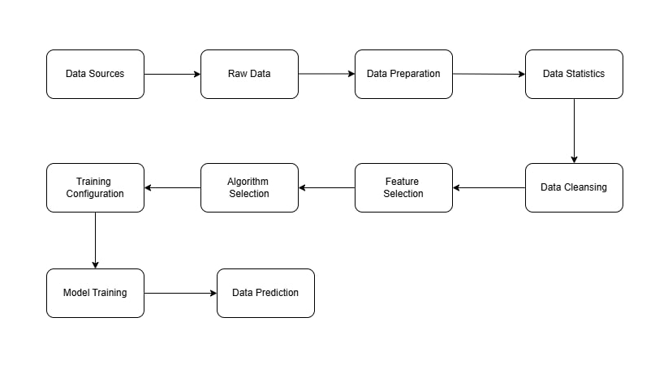

Fig 2.1: MLAA Process Flow Diagram

  - Architecture Diagram

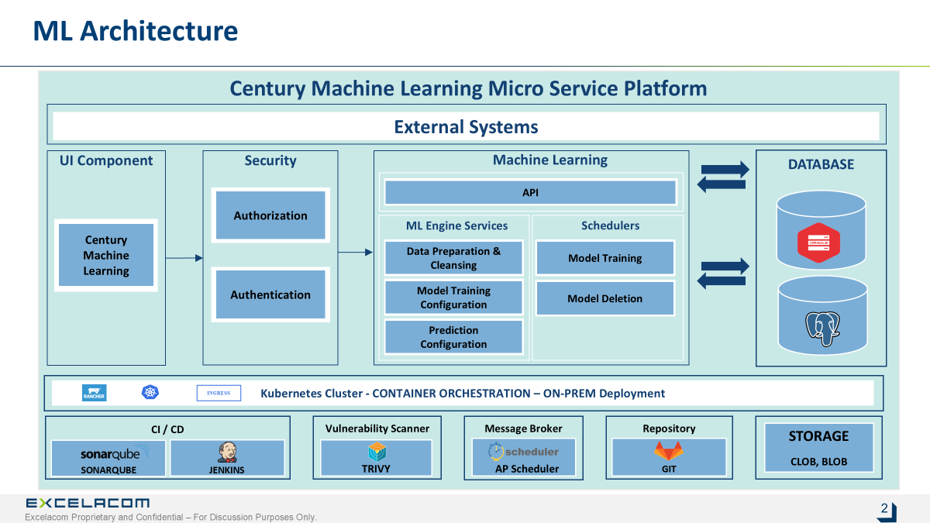

Fig 2.2: MLAA Architecture Diagram
- MLAA Workflow

  - Overview
MLAA workflow details involves five stages of the model lifecycle, all managed and monitored by the Administration module
Machine Learning is a fundamental part of the MLAA platform where we can load data, select significant features, algorithm type selection as well configure the details for model training.
Platform provides user the feasibility to train both Supervised model with different algorithms and Unsupervised model with some specific algorithms.
Platform has an option to do batch and real-time prediction with the base trained(supervised) model.
  - Data Preparation (Ingestion)
- Purpose: Bring raw data into the platform and make it analysis-ready.
- Process Flow:
  - Connect to multiple data sources (databases, server files, local computer).
  - Extract raw datasets.
  - Has option to do:
    - Sampling
    - Splitting
    - Concatenating
    - Merging
    - Database querying
    - Joining
- Derived data can be used for model training and it can be stored in server or exported as CSV, Xlsx, Zip in different file formats
- Output: Structured datasets ready for processing.
  - Data Cleansing & Feature Engineering (Quality & Transformation)
- Purpose: Ensure data quality and transform data into model-ready features.
- Process Flow:
- Handle missing values, invalid, outliers, duplicates.
- Apply normalization, encoding, and standardization.
- Derive new column with multiple techniques like arithmetic operations, string operations and so on
- Generate domain-specific derived features.
- Split data into train, test, and validation sets.
- Store clean and transformed datasets in a feature store.
- Output: High-quality, feature-engineered datasets.
  - Machine Learning (Algorithm Selection & Hyperparameter Tuning)
- Purpose: Train models using curated datasets.
- Process Flow:
- Select algorithms based on problem type (classification, regression, etc.).
- Train multiple models with automated hyperparameter tuning.
- Capture experiment metadata (model parameters, performance, etc.).
- Store trained models and associated metadata
- Output: Candidate models with evaluation metrics.
  - Model Validation & Summary (Performance Metrics & Reporting)
- Purpose: Evaluate model performance and summarize results.
- Process Flow:
- Evaluate models using cross-validation and test datasets.
- Compute key metrics (Accuracy, Precision, Recall, F1, AUC, RMSE, etc.).
- Generate visual and tabular model summary reports.
- Rank models based on performance and compliance criteria.
- Output: Validated and approved model ready for deployment
  - Production Inference (Batch & Real-time Prediction)
- Purpose: Can use trained models for both the prediction.
- Process Flow:
- Choose the trained model needed
- Serve the model as:
  - Batch prediction: via scheduled jobs.
  - Real-time inference: via REST API or streaming endpoint.
- Enable retraining triggers if model degradation is detected.
- Output: Predictions stored in target systems (servers, exports).

  - Administration Module (Lifecycle & Governance)
- Purpose: Manage model versions, file versions with respect to users.
- Process Flow:
- Track Active vs Inactive models, datasets, and projects.
- Archive historical models and data.
- Output: governed ML platform with full lifecycle traceability.
- Functional Description
  - Data Preparation
    - Connecting
The Connecting Tab in the Data Preparation module enables users to establish connections with database schemas for retrieving data directly from a database. Users can configure database connection details such as hostname, port, username, password, and schema name. The system allows users to test, save, or reset connection configurations, and it displays all successfully connected database schemas.
- Users can select specific tables within a connected schema
- Can view statistical information of a chosen table.
- Has an option to export the table or it can be stored in the server.
- With that table we can initiate model preparation by navigating to the Data Cleansing module.
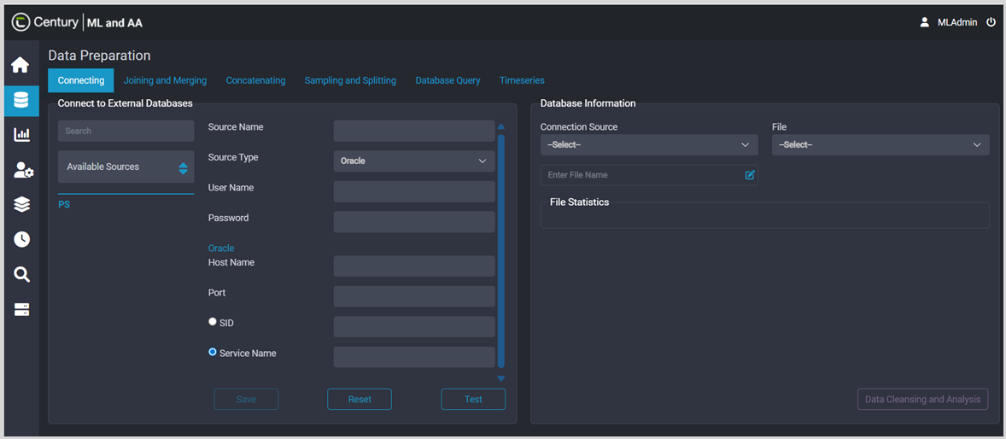
    - Joining and Merging
The Joining and Merging tab allow users to upload two datasets and combine them using various join operations based on user-defined keys.
Users can configure the following parameters:
      - Join Type: Inner, Outer, Left, or Right join.
      - Merge Type: Combine matching (same) or unique data records.
After execution, the system displays detailed file statistics of the merged dataset, including row count, duplicate records, and null value distribution. The merged dataset can then be saved to the server or exported locally in supported formats such as CSV, Excel, JSON, ZIP, and Pickle.
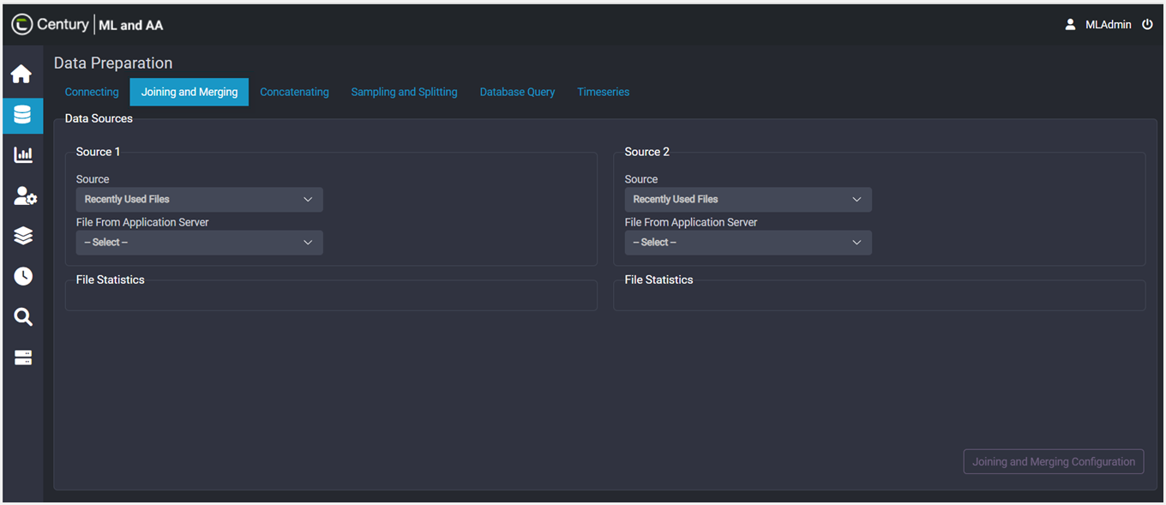

    - Concatenating
- The Concatenating Tab enables users to upload and combine multiple datasets into a single unified dataset. If a column mismatch occurs among the uploaded files, the system identifies the inconsistency and raises an error
- After successful concatenation, the module displays file-level statistics for each dataset and the combined result. The concatenated dataset can be saved to the server or exported locally in various formats including csv, xlsx, json, zip and pickle
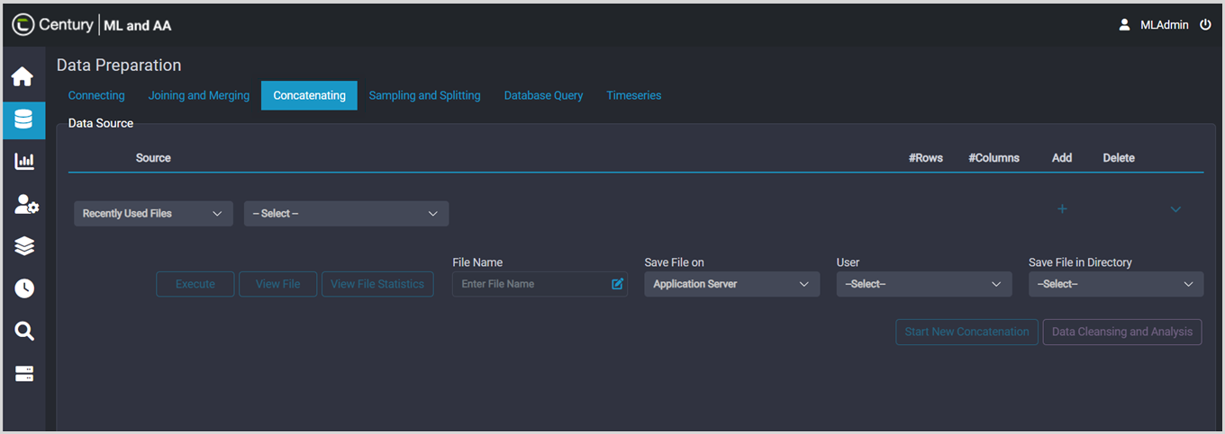

    - Sampling and splitting
- Sampling Tab
The Sampling Tab enables users to create representative subsets of a dataset for quick analysis for model training.
Users can:
- Upload a dataset from the local system or server.
- Select a sampling method (random, stratified, or percentage-based).
- Specify the number of rows or sampling ratio.
The sampled dataset can be saved on the server or exported locally in different formats such as CSV, Excel, JSON, Pickle, and ZIP.
- Splitting Tab
The Splitting Tab allows users to divide a dataset into multiple parts for modular data processing.
Users can:
- Upload a dataset.
- Define the number of splits required.
- View the number of rows allocated per split.
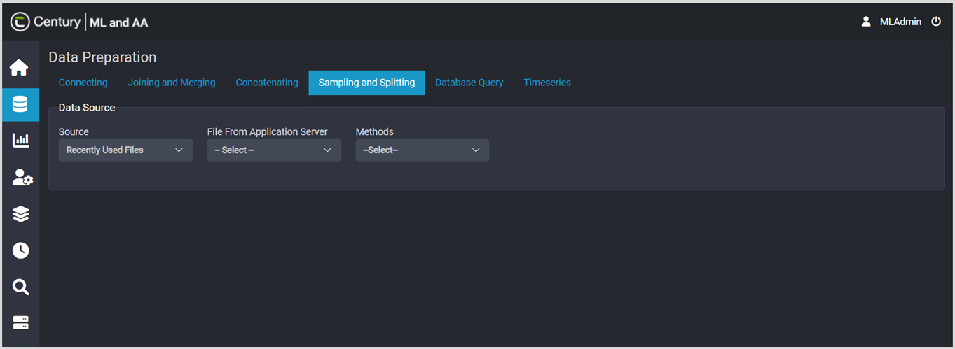
After execution, the system generates separate files for each split, which can be saved on the server or downloaded locally in CSV, Excel, or JSON formats. For example, if four splits are specified, four individual files will be generated and made available for download

    - Database Query
- The Database Query tab in the Data Preparation module allows users to define and execute customized queries involving multiple tables
- Users can select the connection source and upload a file
- Can specify joins and filters to extract the required dataset
- Users can run and save queries, as well as view the list of generated queries
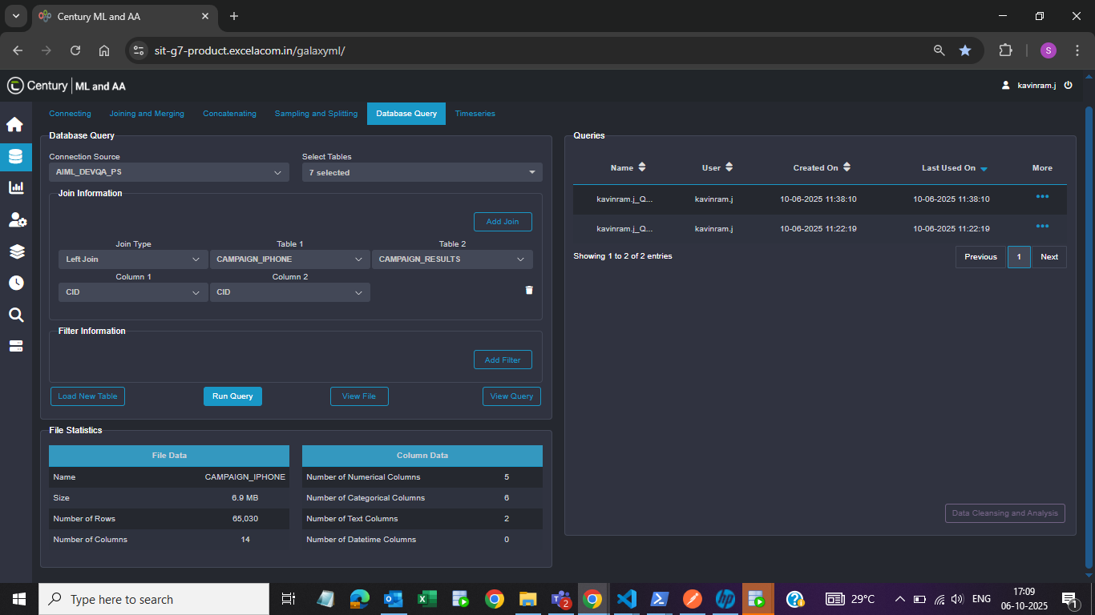
- The resulting data from the executed query can be reviewed through file statistics and is utilized in subsequent stages of the model training process

    - Time Series
- The Time Series tab allows users to upload time series–specific datasets and view the corresponding file statistics
- Users can configure key parameters such as stratification, frequency, operation, group-by column, aggregate column, and covariate column
- The frequency can be selected based on days, minutes, or months
- Users can choose the group-by and aggregate columns to group the dataset according to the selected frequency
- The stratification dropdown allows users to select the target column, which is utilized in the model training process
- The covariate column can also be selected, and this column is used as an additional input feature during model training
- All defined parameters can be saved and reused during subsequent model training sessions
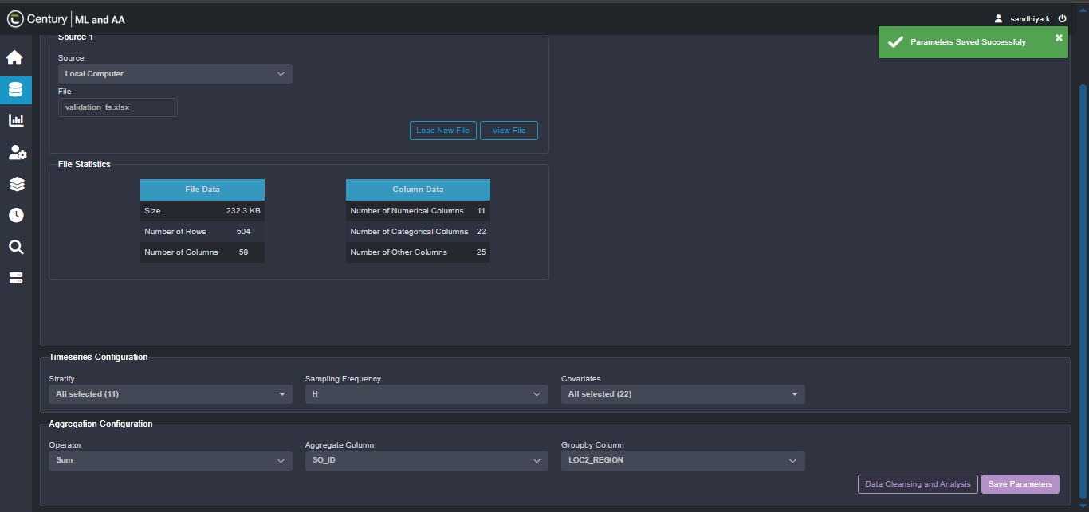
  - Data Cleansing and Analysis
    - Data Ingestion
- Data Ingestion tab in the Data Cleansing module allows users to upload datasets from various sources such as a local computer, application server, or database
- It displays the file size, number of rows, and number of columns in the dataset
- It provides detailed statistics on data quality, including missing, invalid, and suspect records
- It also shows statistics on the number of numerical, categorical, and other types of columns
- User can apply, remove, or replace filters based on specific requirements
- User can view the applied filters and review the data in the Data Preview tab
- User can also start a new project and upload a new file
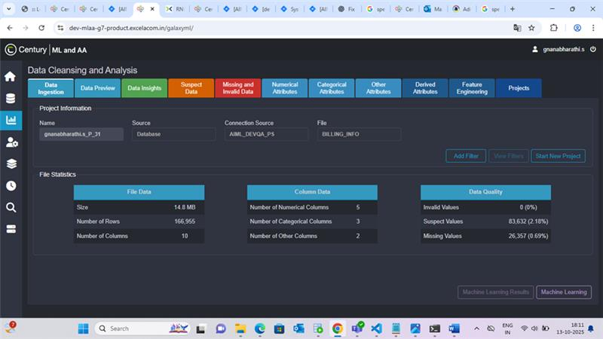

    - Data Preview
- The Data Preview tab in the Data Cleansing module displays a preview of the dataset with up to 1,000 rows
- Users can view the data for each column, with missing and invalid values highlighted in red, and suspect values highlighted in orange for easy identification
- The tab allows users to search values within specific columns, apply filters, and view the updated dataset after filtering
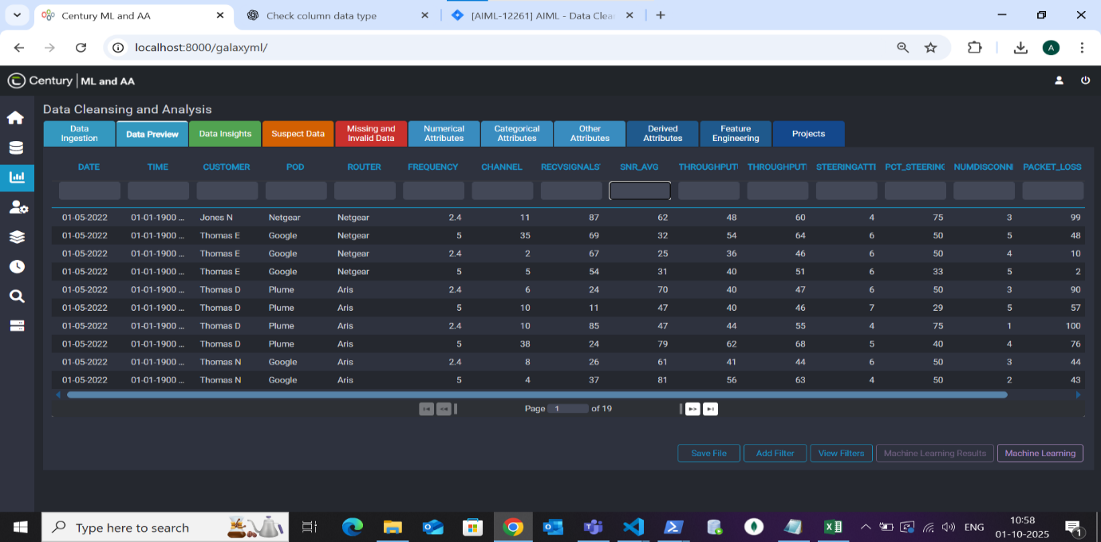
- The dataset can also be saved or downloaded in various formats such as CSV, Excel, Pickle, Zip, Json and can be stored in the user’s directory

    - Data Insights
This tab displays dataset statistics, percentage of invalid, suspect, missing data along with that it show the information of how one attribute correlating with others.
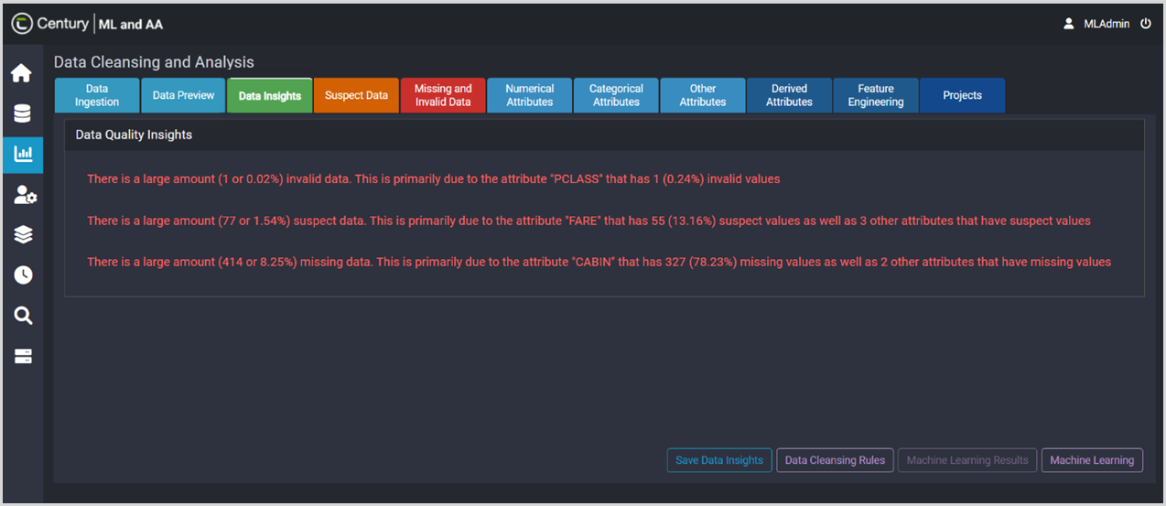

    - Suspect Data
- This tab shows the list of columns which have suspect data (Outliers) along the percentage
- First, it shows Numerical -Suspect data columns followed by categorical and other attributes if exists.
- Each attribute present in this tab has an option to treat the suspect data in different techniques which includes,
    - Remove,
    - Replace with mean, median and mode
    - Custom Logic
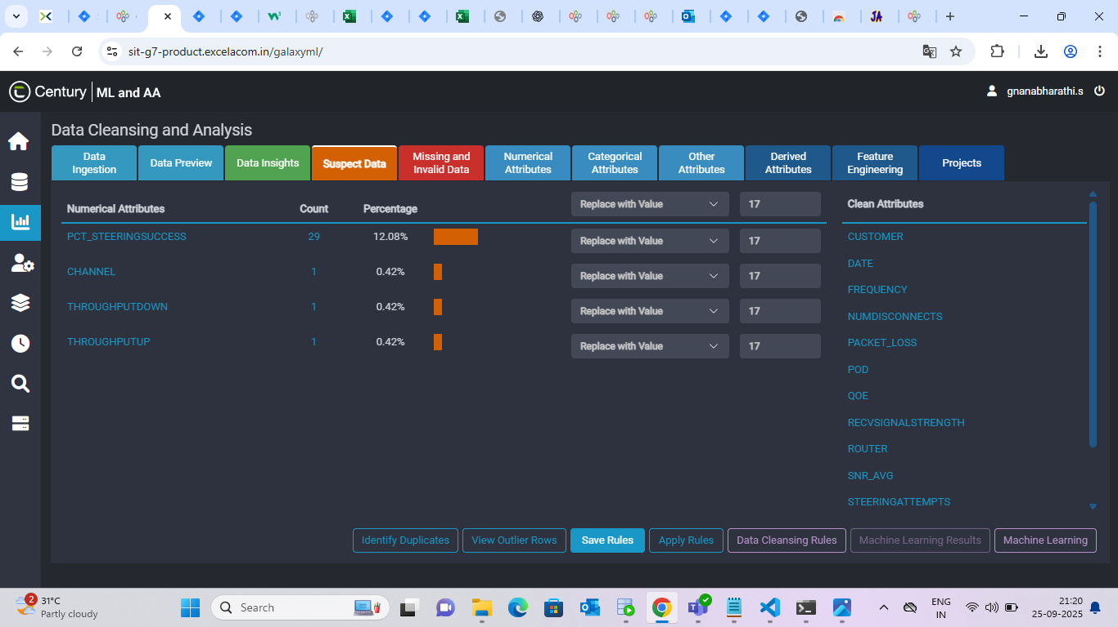

4.2.4.1 Methods for handling Suspect data for Numeric column
              - Remove Row: It removes all rows of that selected column where the suspect value is present.
              - Replace with Mean: It replaces suspect data with the mean of that selected column values.
              - Replace with Median: It replaces suspect data with median of that selected column values.
              - Replace with Mode: It replaces suspect data with mode of selected column values.
              - Replace with Value: It replaces suspect data with value typed by user.
              - Clear Outliers: It clears the suspect data.
              - Replace with custom logic: If replaces suspect data based on conditional check on another column values.
4.2.4.2 Methods for handling Suspect data for Categorical column
              - Remove Row: It removes all rows of that selected column where the suspect value is present.
              - Replace with Mode: It replaces suspect data with mode of selected column values.
              - Replace with Value: It replaces suspect data with value typed by user.
              - Replace with custom logic:
              - It replaces suspect data based on conditional check on another column values
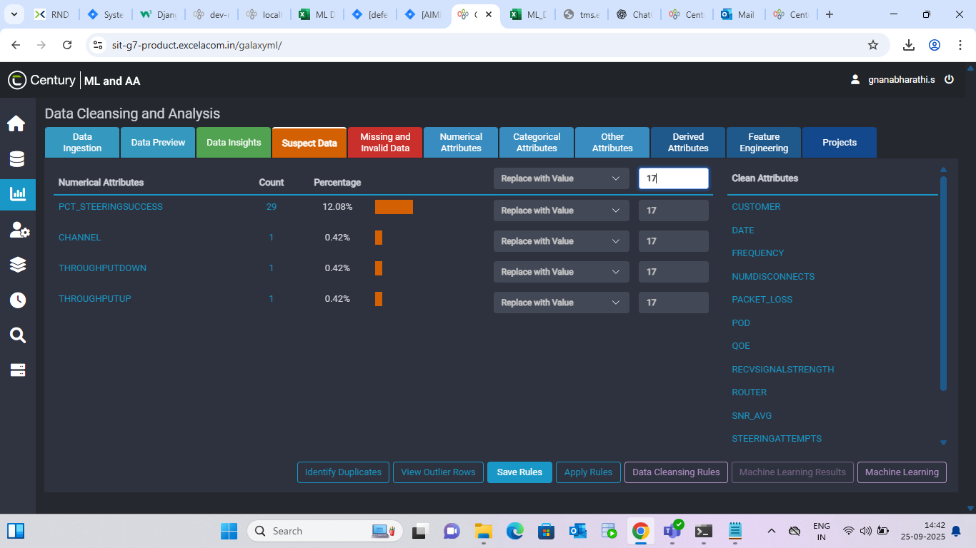

    - Missing and Invalid Data
This tab shows a list of columns which have Missing and Invalid data and dropdown of methods for handling invalid, missing data present in the respective column. The display of this tab is in this order: Numerical Missing data, Categorical Missing data, Numerical Invalid data, Categorical Invalid Data
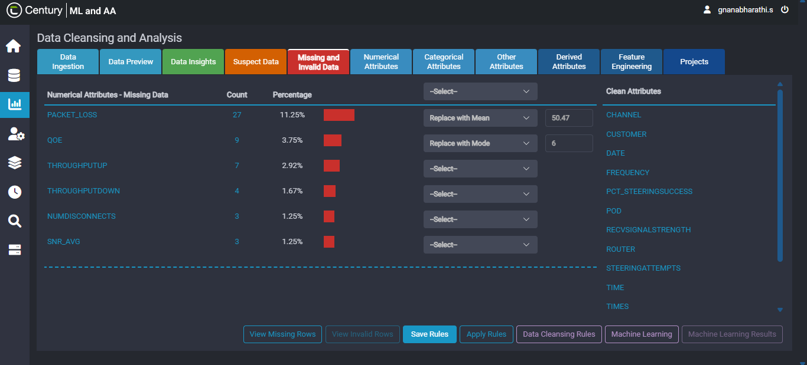
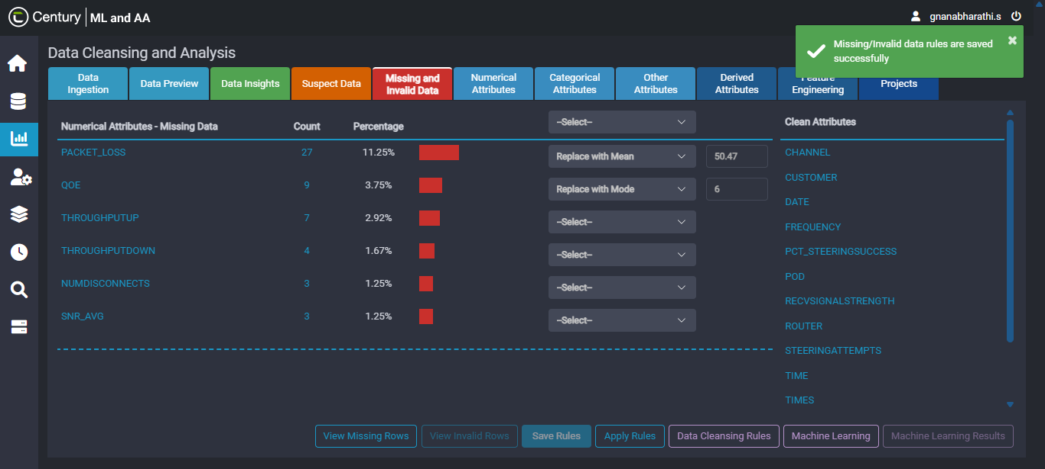

4.2.5.1 Methods for handling Missing data for Numeric column
              - Remove Row: It removes all rows of that selected column where the missing value is present.
              - Replace with Mean: It replaces missing data with the meaning of selected column values.
              - Replace with Median: It replaces missing data with median of selected column values.
              - Replace with Mode: It replaces missing data with mode of that selected column values.
              - Replace with Value: It replaces missing data with value typed by user.
              - Replace with Interpolate: It replaces missing data by estimating based on known values present in the selected column.
              - Replace with custom logic: It replaces missing data based on conditional check on another column values.

4.2.5.2 Methods for handling Missing data for Categorical column
              - Remove Row: It removes all rows of that selected column where the missing value is present.
              - Replace with Mode: It replaces missing data with mode of that selected column values.
              - Replace with Value: It replaces missing data with value typed by user.
              - Replace with custom logic: It replaces missing data based on conditional check on another column values.

4.2.5.3 Methods for handling Invalid data for Numeric column
              - Remove Row: It removes all rows of that selected column where the invalid value is present.
              - Replace with Mean: It replaces invalid data with mean of selected column values.
              - Replace with Median: It replaces invalid data with median of that selected column values.
              - Replace with Mode: It replaces invalid data with mode of selected column values.
              - Replace with Value: It replaces invalid data with value typed by user.
              - Replace with Interpolate: It replaces invalid data by estimating based on known values present in the selected column.
              - Replace with custom logic: It replaces invalid data based on conditional check on another column values.
4.2.5.4 Methods for handling Invalid data for Categorical column
              - Remove Row: It removes all rows of that selected column where the invalid value is present.
              - Replace with Mode: It replaces invalid data with mode of selected column values.
              - Replace with Value: It replaces invalid data with value typed by user.
              - Replace with custom logic: It replaces invalid data based on conditional check on another column values.

    - Numerical Attributes
- This tab displays a list of columns which are numerical columns in a table format. It shows range, count of unique values, mean, median, mode, standard deviation, number of missing data, number of suspect data, and number of invalid data
- If the column name in the table is clicked, it sorts out the values present in that column. If hyper link present in the row is clicked then that column statistics will be displayed. If any row (without any hyperlink) is clicked, the row expands, and the graph is displayed
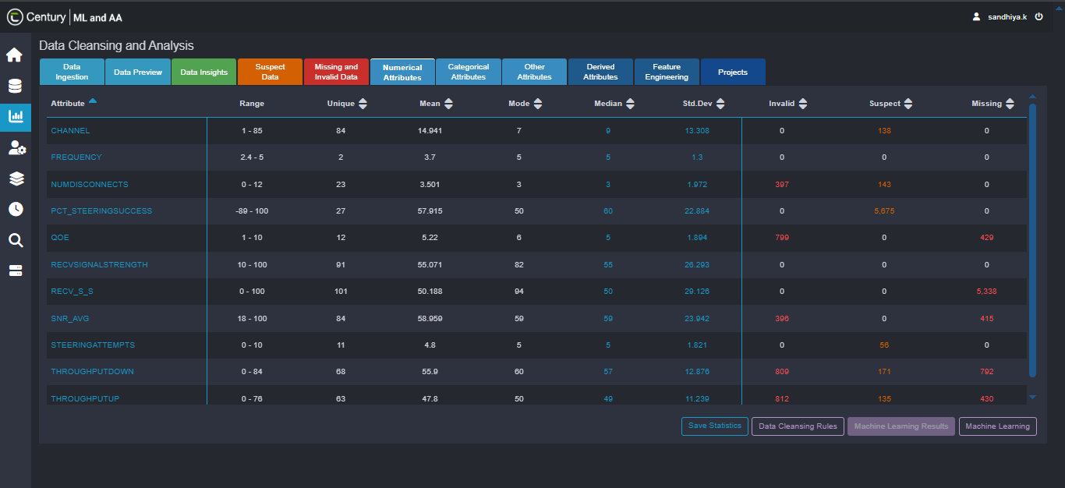
- Next to the graph there is an icon, if the icon is clicked, the option to save the graph is displayed. The graph can be saved in PNG, JPEG, and SVG
    - Categorical Attributes
- The Categorical attributes tab in Data Cleansing and Analysis represent data values grouped into categories, such as nominal values (e.g., state, gender) or ordinal values. The View Categorical Attributes option allows you to explore these attributes from the uploaded datasheet.
- When an attribute is selected, the application provides various options to visualize and interact with the data effectively. It displays both the Histogram Chart and the Frequency Chart to help users understand data distribution and frequency patterns.
- Hovering over the blue bars or red points on the histogram displays detailed information through tooltips.
- The chart’s context menu includes options to view in full screen or download the chart as a PNG, JPEG, or SVG image.
- The Save Statistics option enables users to download the categorical attributes table to their local system for further analysis.

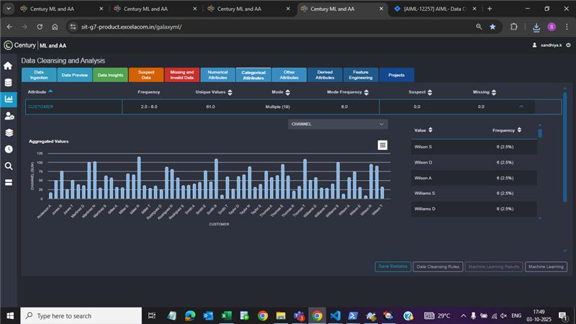

    - Other Attributes
- The Other Attributes tab in Data Cleansing and Analysis represents data fields that contain only text values, excluding numeric and categorical data. The View Other Attributes option allows you to explore and review these text-based attributes from the uploaded datasheet.
- When an attribute is selected, the application provides various options to visualize and interact with the data effectively. It displays both the Histogram Chart and the Frequency Chart to help users understand data distribution and frequency patterns.
- Hovering over the blue bars or red points on the histogram displays detailed information through tooltips.
- The chart’s context menu includes options to view in full screen or download the chart as a PNG, JPEG, or SVG image.
- The Save Statistics option enables users to download the categorical attributes table to their local system for further analysis.
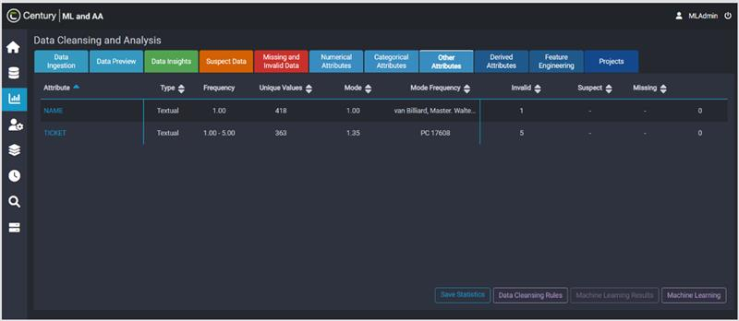

    - Derived Attributes
The Derived Attributes tab in Data Cleansing and Analysis represents attributes whose values are computed or derived from other attributes within the same dataset. For example, the attribute Age can be derived from Date of Birth. The Create Derived Attributes Using Pre-defined Rules option allows you to generate derived attributes using built-in rules such as Encoding, Arithmetical, Splitting, and Date-Time Conversion. This section explains how to create derived attributes using these predefined rules.
The Derived Attributes feature allows you to perform various operations on data, including Arithmetic, Logical, Quality, String, Time, and Time Series operations. These cover a wide range of tasks such as performing mathematical calculations, applying conditional rules, handling data quality issues, manipulating text values, converting, and calculating date or time-based values, and processing time-dependent or sequential data.
- Derived Attributes Using File-Based Rule
The Derived Attributes Using File-Based Rules option allows users to create derived attributes by configuring rules defined in external files. These file-based rules support advanced data transformations, such as generating lookup-based derived values or applying predefined logic from uploaded files.
- Derived Attributes Using Code-Based Rules
The Derived Attributes Using Code-Based Rules option allows users to generate derived attributes by configuring custom, file-based rules. These rules enable advanced data transformations, such as creating lookup-based derived values or applying user-defined logic through code
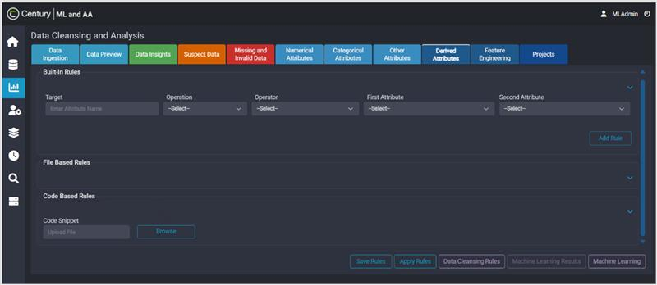

    - Feature Engineering
The Feature Engineering tab in Data Cleansing and Analysis helps prepare input datasets that meet machine learning algorithm requirements. It involves selecting, transforming, and creating new features from raw data to enhance model performance. The Normalizing Numerical Attributes option allows users to rescale numerical values to a fixed range, typically between 0 and 1, where the smallest value becomes 0 and the largest becomes 1. This normalization process ensures that all numerical attributes contribute equally to the model’s learning process.
The Feature Engineering tab in Data Cleansing and Analysis allows users to perform a range of data transformation operations to prepare datasets for machine learning models. It supports several actions for both numerical and categorical attributes to enhance data quality and consistency.
For numerical attributes, users can:
- Scale or standardize values using Min-Max Scaler or Standard Scaler.
- Round up decimal values to the nearest integer.
- Remove specific rows or entire attributes based on conditions.
- Strip unwanted spaces from column values.
- Scale values up or down by a given factor.
- Convert numerical data to categorical or textual types when needed.
For categorical attributes, users can:
- Encode data using methods like Label Encoder or One Hot Encoder.
- Clean data by removing rows or attributes, or by trimming spaces.
- Adjust text formatting by converting values to lowercase, uppercase, or title case.
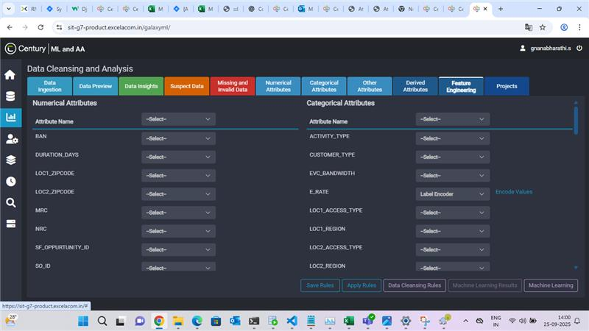

  - Machine Learning
    - Data Ingestion
- Data Ingestion tab in the Data Cleansing module allows users to upload datasets from various sources such as a local computer, application server, or database
- It displays the file size, number of rows, and number of columns in the dataset
- It provides detailed statistics on data quality, including missing, invalid, and suspect records
- It also shows statistics on the number of numerical, categorical, and other types of columns
- Users can apply, remove, or replace filters based on specific requirements
- User can view the applied filters and review the data in the Data Preview tab
- User can also start a new project and upload a new file
    - Data Preview
- The Data Preview feature helps you view and explore the structured information from your selected data source in a clear and organized format.
- It allows you to quickly check the content, format, and structure of the dataset before moving on to any processing or analysis. This ensures that the data you’re working with is accurate, properly formatted, and ready for further steps

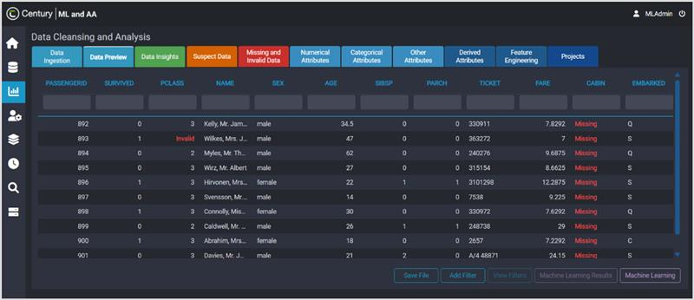
    - Correlation Matrix
    - The Correlation Matrix helps to understand how different variables in your dataset are related to each other. It’s presented as a table where each cell shows the correlation coefficient — a numerical value that indicates how strongly two variables move together
    - In simple terms, it helps to see whether one variable increase or decreases when another does, and by how much
    - The correlation matrix is often used to:
  - Get an overview of your data before running complex analyses or building models
  - Identify relationships between variables, such as which ones are positively or negatively related
  - Detect patterns or dependencies that could affect model’s accuracy or interpretability

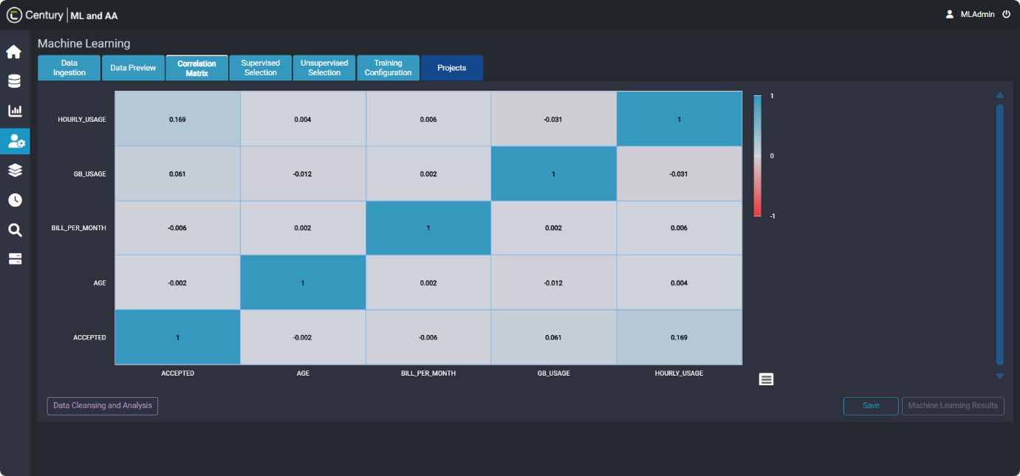
    - Supervised Selection
    - The Supervised Selection stage is a key part of the machine learning workflow where you decide what type of model you want to create using labelled data — that is, data that already includes both the input features and the correct output values (or labels)
    - The main goal of this step is to choose the right type of machine learning algorithm based on what you want your model to achieve. Different problems require different kinds of models — for example:
  - Classification models are used when the output is a category or label (e.g., predicting whether a passenger survived or not)
  - Regression models are used when the output is a continuous numeric value (e.g., predicting a person’s age or the price of a house)
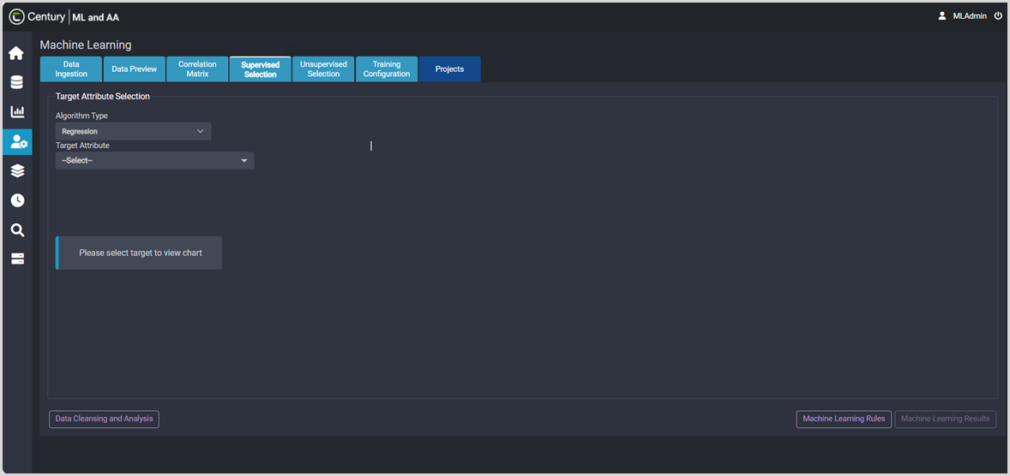
Choosing the correct model type is essential because it determines how the algorithm interprets the data, learns from it, and makes predictions
    - Unsupervised Selection
- Unsupervised learning is a type of machine learning where the algorithm analyses data without predefined labels or outcomes. Unlike supervised learning (where the model is trained on labelled data with known outputs), unsupervised learning focuses on discovering hidden patterns, relationships, and groupings in datasets
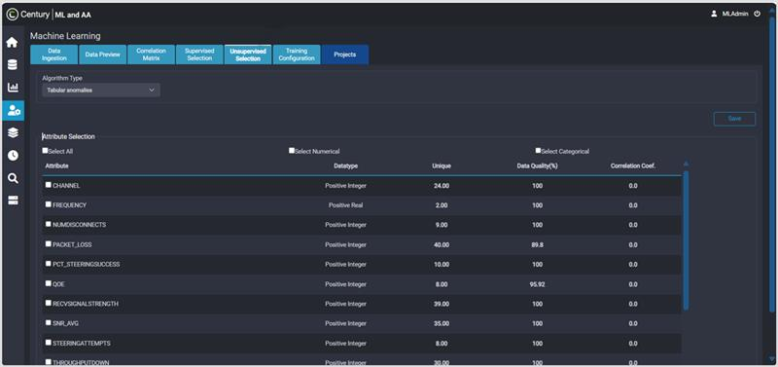
- This makes it highly valuable for analysing large, unstructured, or unlabelled data, such as customer behaviour, network performance metrics, and fraud detection

    - Training Configuration
- The Training Configuration in Machine Learning allows users to configure and initiate model training by selecting the desired number of models, Algorithms, and corresponding hyperparameters
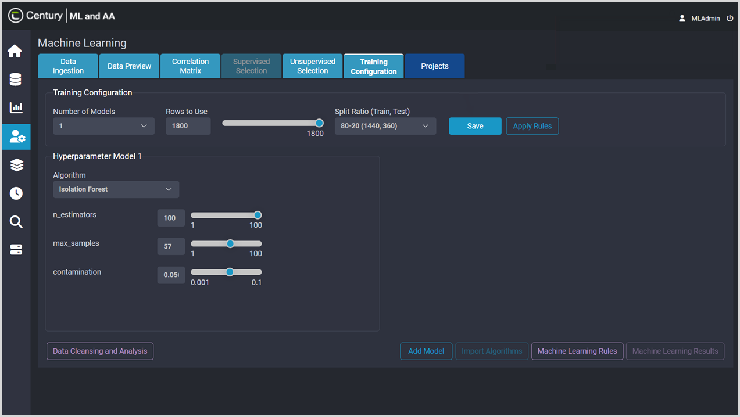
- This tab helps users train machine learning models based on their dataset and specific requirements and also provides flexibility to experiment with different configurations. It ensures that users can build and refine models that best fit their data.
    - View Projects
- The View Projects in Machine Learning and Advance Analytics application allows users to access and manage projects that have been previously created within the application. It provides a centralized interface to review essential project details and perform related actions efficiently
- It enables the users to filter projects, download associated datasets, and monitor project state. Users can also move projects to the Inactive state when they are no longer needed, helping maintain a clean and organized workspace
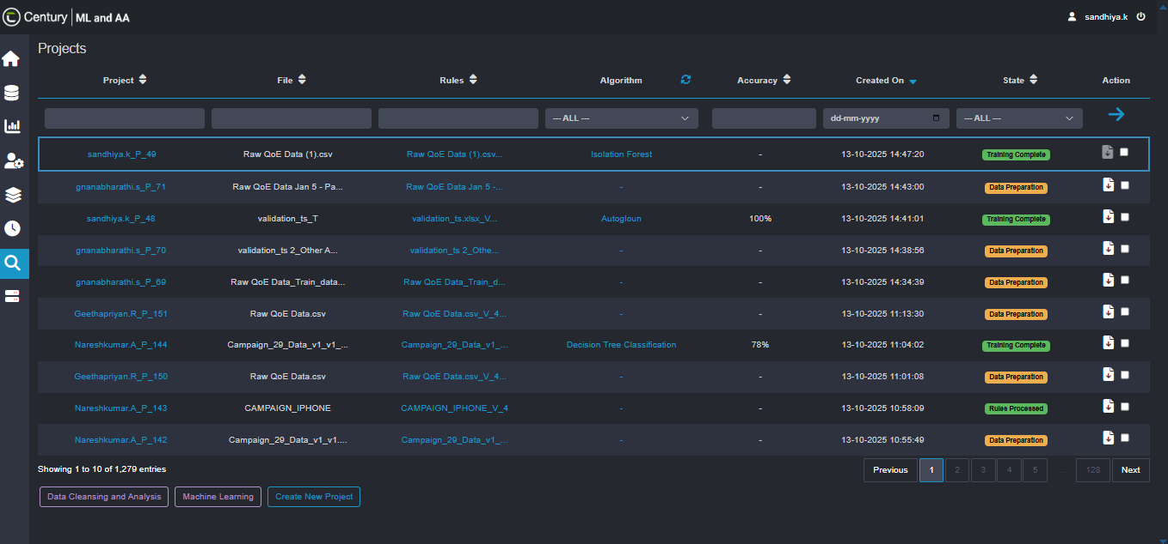

  - Batch Prediction
- The Batch prediction allows users generate predictions for a large set of input data at once, rather than one record at a time. It enables the users to upload the relevant dataset for prediction
- It ensures that user can view the predicted result for the target variable and also the users to download the predictions in various format as per their needs
- It also ensures users to view the predicted results. It also enables users to download the prediction outputs in various formats based on their requirements. This ensures flexibility in accessing and utilizing the prediction results for further analysis and reporting
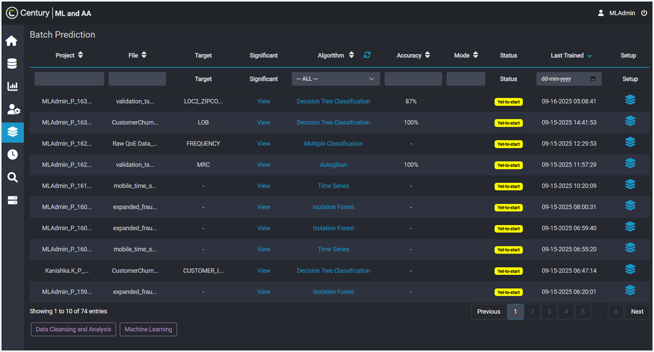

  - Real Time Prediction
    - The Real-time Prediction feature allows users to generate predictions instantly for a single input record based on the trained model.
    - Provides an interactive interface where users can manually enter or modify the values of significant attributes and obtain immediate prediction results
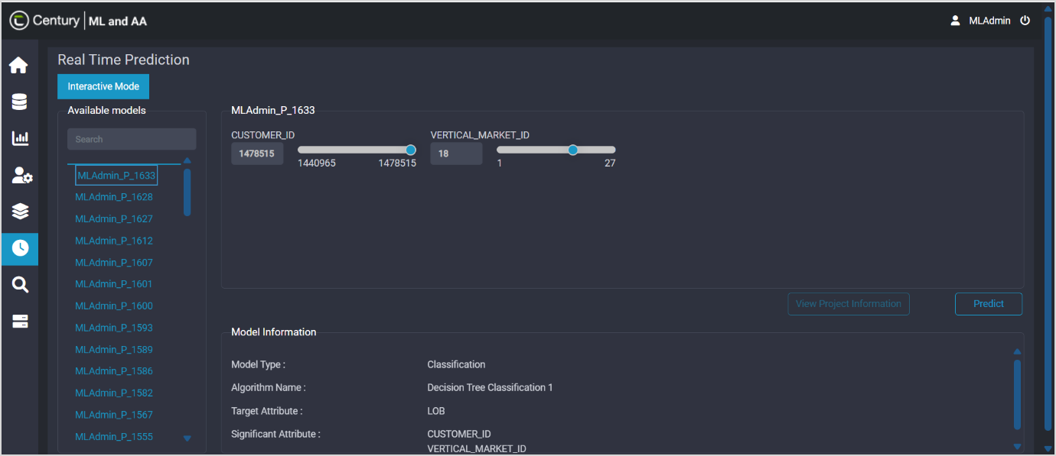
    - Helps users understand how changes in specific input parameters influence the model’s output. Users can experiment with different input combinations to observe real-time outcomes without retraining the model

  - Administration
- The Administration module in MLAA platform allows the users to view and manage the files stored within the application
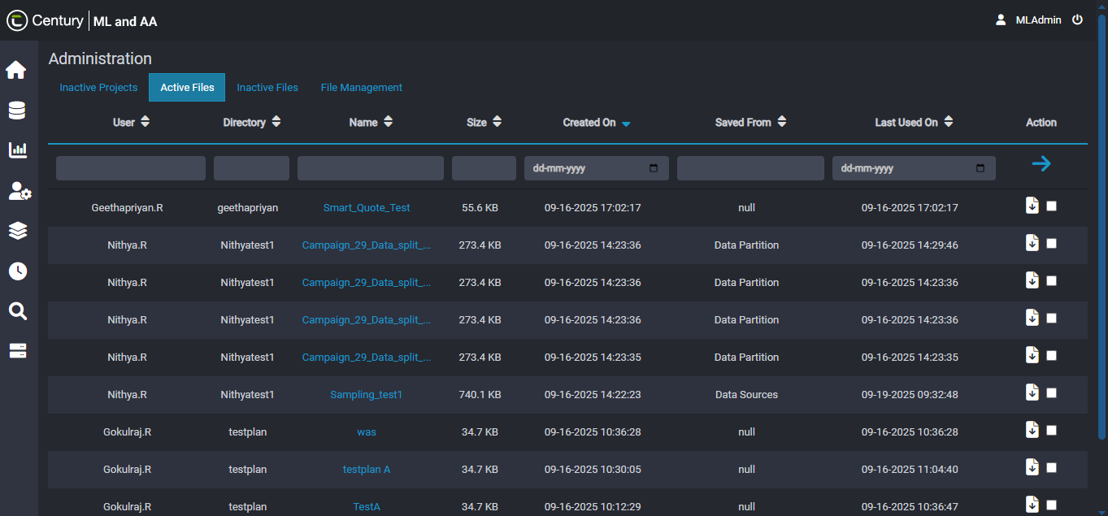
- Allows users to create directories, upload files, and manage them efficiently within the application. It enables users to move the outdated files and unused files to Inactive state, helping maintain a clean and organized workspace

- Sequence Diagram
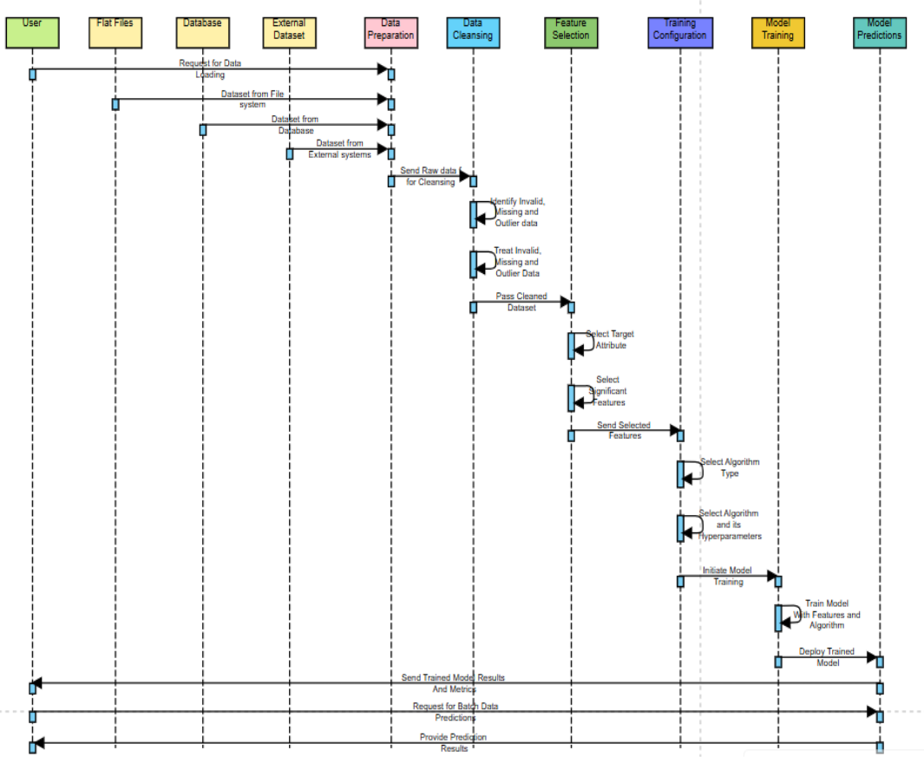
Fig 5: Sequence Diagram

- Class Diagram

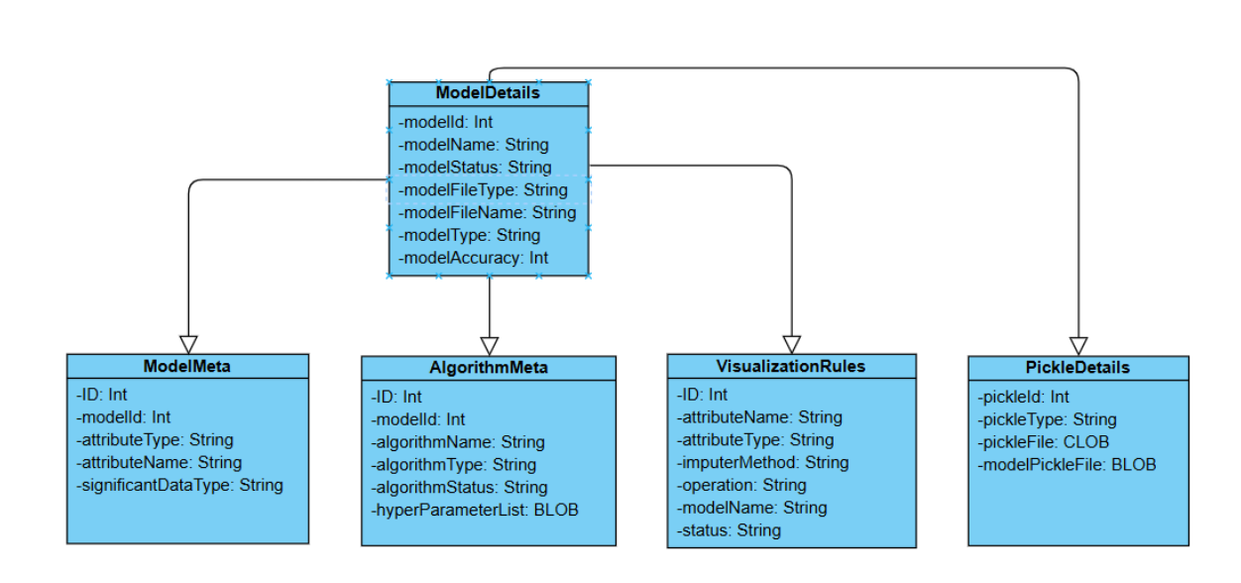

Fig 6: Class Diagram
- State Diagram

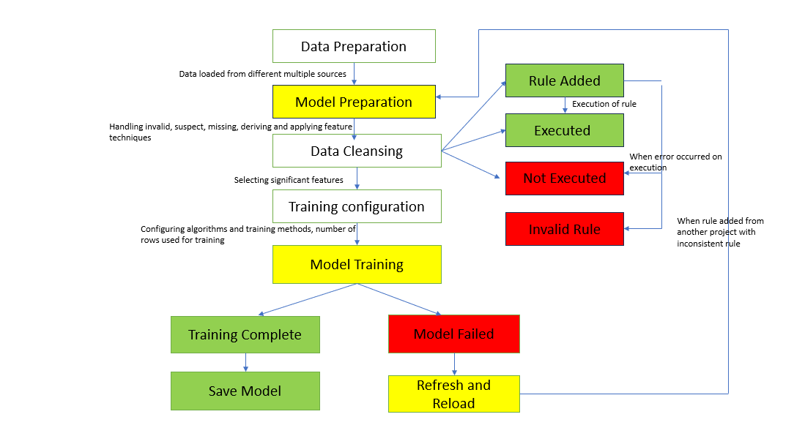

Fig 7. State Diagram

- API Specifications

8.1 API Listing
S.NO | API | Definition
1 | loadPage | This API is for rendering the homepage of the application based on the provided divId(holds the page name).
2 | Save Feature Selection | This API is for saving the selected features of a model.
3 | Retrieval of List of Trained Models | This API is for retrieving the paginated list of model details
4 | Upload Train Data | This API is for reading data from a multiple sources of the platform
5 | Initiate Model Training | This API is for initiating the machine learning model training process
6 | Save Algorithm Configuration | This API is for saving the configured algorithms
7 | Perform Predictions | This API is for performing prediction based on a trained model
8 | Save Outlier Rules | This API is for saving outlier rules in the database

loadPage – ML Application Homepage

8.2.1 Purpose
An API endpoint that acts as a page loader that renders the homepage of the application based on the provided divId(holds the page name). Depending on the divId, it looks up which HTML template and data loader should be used. Finally, the endpoint returns the HTML page.

API URL
https://dev-mlaa-g7-product.excelacom.in/galaxymlService/api/loadPage

8.2.3 Request Method
POST Method

8.2.4 API Request Attribute Details
Attribute Name | Attribute Type | Length | Required | Description | Galaxy Attribute
Flag | String | 400 | Yes | Indicates the type of action, e.g., "REFRESH". | Not an UI parameter.
session_id | String | 500 | Yes | Unique identifier for the user session. | Not an UI parameter.
Username | String | 400 | Yes | The username of the current user. | Not an UI parameter.
divId | String | 1000 | Yes | Specifies which part of the page or functionality to load. (#createModel, #viewModel, #datasource, #rpa) | Not an UI parameter.
model_id | Integer | 100 | Yes | The ID of the model to load or interact with. Required if `divId` is not provided and `curr_project_flag` is not 'true'. | Not an UI parameter.
curr_project_flag | String | 600 | Yes | If 'true', indicates the current project's `divId` should be used. | Not an UI parameter.
Page | String | 600 | Yes | Additional context for the page load, e.g., 'data_ingestion', 'datasrc', 'REFRESH'. | Not an UI parameter.
data_source | String | 600 | Yes | Specifies the data source type when `page` is 'datasrc', e.g., "Sheet", "oss", "App", "Database", "Intelligent Agent", "overall_created", "customdb". | Not an UI parameter.
connection_source | String | 600 | Yes | The name of the connection source, relevant for database operations. | Not an UI parameter.
model_file_name | String | 600 | Yes | The name of the model file. | Not an UI parameter.

8.2.5 API Response Attribute Details
Attribute Name | Attribute Type | Length | Required | Description
usernameML | String | 400 | Yes | Machine learning related session values, relevant for `"#createModel"` and `"#dataPreparation"`.
query_usernameML | String | 500 | Yes | Machine learning related session values, relevant for `"#createModel"` and `"#dataPreparation"`.
directory_nameML | String | 400 | Yes | Machine learning related session values, relevant for `"#createModel"` and `"#dataPreparation"`.
connection_sourceML | String | 1000 | Yes | Machine learning related session values, relevant for `"#createModel"` and `"#dataPreparation"`.
default_model_name | Integer | 100 | Yes | A generated default model name, relevant for `"#createModel"` and `"#dataPreparation"`.
train_data_upload_page | String | 600 | Yes | Rendered HTML for the model creation page, relevant for `"#createModel"` and `"#dataPreparation"`.
session_flag | String | 600 | Yes | Indicates if a new session was created, relevant for `"#createModel"` and `"#dataPreparation"`.
current_user | String | 600 | Yes | The username of the current user, relevant for `"#createModel"` and `"#dataPreparation"`.
file_exist_flag | Boolean | True/False | Yes | Present when `divId` is `"#fileManagement"`, indicates if 'Distribution.py' exists.
default_chat_name | String | 600 | Yes | Present when `divId` is `"#chatBot"`, provides a default name for a new chat session.
session_flag | Boolean | True/False | Yes | Indicates if a new session was created, relevant for `"#createModel"` and `"#dataPreparation"`.
trainDataSource | String | 600 | Yes | The type of training data source, specific to `"#dataPreparation"` when `page` is 'datasrc'.
new_model_id | Integer | 100 | Yes | The ID of the newly created model, specific to `"#dataPreparation"` when `page` is 'datasrc'.
id_trainDataTable | String | 1000 | Yes | Identifier for the training data table, specific to `"#dataPreparation"` when `page` is 'datasrc'.
id_trainDataSource | String | 1000 | Yes | Identifier for the training data source, specific to `"#dataPreparation"` when `page` is 'datasrc'.
train_data_page_datasrc | String | 1000 | Yes | Rendered HTML for the model creation page with data source context, specific to `"#dataPreparation"` when `page` is 'datasrc'.
train_data_upload_page_new | String | 1000 | Yes | Rendered HTML for the model creation page, relevant for `"#createModel"` and `"#dataPreparation"`.
html1 | String | 6000 | Yes | Additional HTML content, specifically for `"#realTimePrediction"` (e.g., significant attributes).
id_modelname | String | 1000 | Yes | Model name prefixed with 'id_', specific to `"#realTimePrediction"`.
super_user_flag | Boolean | True/False | Yes | Indicates if the current user has superuser privileges.
model_id | Integer | 100 | Yes | The ID of the current model, derived from session or request.
Html | String | 6000 | Yes | The rendered HTML content for the requested `divId`.

saveFeatureSelection – Stores Significant Attributes

8.3.1 Purpose
An API endpoint that saves the selected features for a model accepts a request body containing modelName (the name of the model), targetList (the dependent variable(s) or prediction targets), target_class (the specific class within the target if applicable), data_quality (indicators or metrics about the quality of the input data), attribute_selection_method (the algorithm or approach used to choose features), significant_selectedColumnList (the final list of selected features or columns), and session_id (to authenticate and associate the request with a user session). The endpoint validates this payload, verifies that the session is authorized, and then persists the selected features and related metadata into the model’s configuration store, returning a structured response confirming successful saving or updating of the feature selection.

8.3.2 API URL
https://dev-mlaa-g7-product.excelacom.in/galaxymlService/api/saveFeatureSelection

8.3.3 Request Method
POST Method

8.3.4 API Request Attribute Details
Attribute Name | Attribute Type | Length | Required | Description | Galaxy Attribute
modelName | String | 400 | Yes | The name of the model. | Name
file | File | - | Yes | The uploaded file. | Not an UI parameter.
id_fileoption_list | String | 400 | Yes | File option list ID. | Not an UI parameter.
connectionSource | String | 600 | Yes | Specifies the schema name | Not an UI parameter.
ossSource | String | 600 | Yes | When S3 is source is selected. | Not an UI parameter.
directory_list | String | 600 | Yes | Represents the directory | Not an UI parameter.
trainDataTable | String | 600 | Yes | Training data table name. | Not an UI parameter.
csvfile_list | String | 500 | Yes | Represents the file name when Database is selected. | Not an UI parameter.
targetList | String | 500 | Yes | The name of the target attribute. | Target Attribute
target_class | String | 400 | Yes | The target class for classification models. | Not an UI parameter.
data_quality | Integer | 1000 | Yes | Data quality percentage. | Required Data Quality
attribute_selection_method | String | 100 | Yes | The method used for attribute selection. | Attribute Selection Method
significant_selectedColumnList | Array of Strings | 600 | Yes | List of selected significant columns. | Attribute(Check Box)
session_id | String | 600 | Yes | The ID of the current user session. | Not an UI parameter.
username | String | 300 | Yes | The current User | Not an UI parameter.

8.3.5 API Response Attribute Details
Attribute Name | Attribute Type | Length | Required | Description
message | String | 4000 | Yes | If the operation was successful. (Success/Failure)
warning_message_flag | Boolean | True/False | Yes | Flag indicating if any warnings were generated.
silder_max_value | Integer | 100 | Yes | Maximum value for a slider.
target_chosen_val | String | 1000 | Yes | The chosen target attribute.
Added_attr_list | Array of Strings | 6000 | Yes | List of added attributes.

getPaginatedModelList – Displays Project List

8.4.1 Purpose
This API endpoint that retrieves the paginated list of model details based on various filtering and sorting parameters provides a unified interface for browsing or searching models. It accepts query parameters such as page number, page size, filter criteria, and sort order to narrow down the results, validates them, and applies the conditions to the underlying data store. The endpoint then returns a paginated response containing project(model) details such as name, status, user, creation date, and other metadata. This allows clients to efficiently view and navigate all listed projects while supporting scalable filtering, sorting, and pagination for large datasets.

8.4.2 API URL
https://dev-mlaa-g7-product.excelacom.in/galaxymlService/api/getPaginatedModelList

8.4.3 Request Method
POST Method

8.4.4 API Request Attribute Details
Attribute Name | Attribute Type | Length | Required | Description | Galaxy Attribute
session_id | String | 4000 | Yes | The ID of the current user session. | Not an UI parameter.
username | String | 1000 | Yes | The username associated with the session. | Not an UI parameter.
table_name | String | 1000 | Yes | The name of the table (though not directly used in the provided logic for filtering). | Not an UI parameter.
status | String | 1000 | Yes | The status of the models to filter by (default: "Active"). | Not an UI parameter.
start | Integer | 100 | Yes | The starting record index for pagination (default: 0). | Not an UI parameter.
length | Integer | 100 | Yes | The number of records to return per page (default: 10). | Not an UI parameter.
draw | Integer | 100 | Yes | A counter for DataTables requests (default: 1). | Not an UI parameter.
order | Array | - | Yes | An array of objects specifying column sorting. | Not an UI parameter.
column | Integer | 100 | Yes | The index of the column to sort by. | Not an UI parameter.
dir | String | 1000 | Yes | The sorting direction (`asc` or `desc`). | Not an UI parameter.
columns | Array | - | Yes | An array of objects describing each column, used for searching and sorting. | Not an UI parameter.
data | String | 400 | Yes | The name of the column data. | Not an UI parameter.
name | String | 400 | Yes | The name of the column. | Not an UI parameter.
searchable | Boolean | True/False | Yes | Indicates if the column is searchable. | Not an UI parameter.
orderable | Boolean | True/False | Yes | Indicates if the column is orderable. | Not an UI parameter.
search | Object | - | Yes | Search parameters for the column. | Not an UI parameter.
value | String | 700 | Yes | The search term. | Not an UI parameter.
regex | Boolean | True/False | Yes | Indicates if the search term is a regex. | Not an UI parameter.

8.4.5 API Response Attribute Details
Attribute Name | Attribute Type | Length | Required | Description
data | Array | - | Yes | A list of model detail objects.
model_instance_id | String | True/False | Yes | Unique ID for the model instance.
model_id | String | 100 | Yes | ID of the model.
model_name | String | 1000 | Yes | Name of the model.
model_version | String | 6000 | Yes | Version of the model.
model_file_name | String | 1000 | Yes | Name of the model file.
model_file_type | String | 2000 | Yes | Type of the model file.
created_on | String | 1000 | Yes | Timestamp when the model was created (format: `MM/DD/YY HH:MM:SS`).
model_type | String | 2000 | Yes | Type of the model (e.g., Classification, Regression).
last_trained_on | String | 1000 | Yes | Timestamp of the last training (format: `MM/DD/YY HH:MM:SS`).
accuracy | Integer | 100 | Yes | Accuracy of the model.
model_status | String | 2000 | Yes | Current status of the model.
train_status | String | 2000 | Yes | Training status of the model.
final_status | String | 2000 | Yes | Final status of the model.
model_visibility | String | 1000 | Yes | Visibility status of the model.
rule_name | String | 2000 | Yes | Name of the rule associated with the model.
algorithm_name | String | 2000 | Yes | Name of the algorithm used.
algorithmtype_status | String | 2000 | Yes | Status of the algorithm type.
project_current_status | String | 2000 | Yes | Current status of the project.
project_Meta | Object | - | Yes | Metadata related to the project.
current_mod_name | String | 2000 | Yes | The name of the current model being viewed.
draw | Integer | 100 | Yes | The `draw` value from the request.
ml_results_navi_flag | Boolean | True/False | Yes | Flag indicating if ML results navigation is available.
recordsTotal | Integer | 100 | Yes | Total number of records before filtering.
recordsFiltered | Integer | 100 | Yes | Total number of records after filtering.
is_model_training | Boolean | True/False | Yes | Flag indicating if any model is currently training.

uploadTrainData – Uploads Dataset

8.5.1 Purpose
This API enables the user to read data from a file, an app, a database as a DataFrame and calculate data types and statistics for the DataFrame provides a unified way to ingest data from multiple sources and immediately profile it. This function takes the specified source, loads the data into a pandas DataFrame, and then computes the column data types along with descriptive statistics, giving a quick overview of the dataset’s structure and quality. It also calculates the suspect, missing and invalid data and provides preview of the data and insights of the data.

8.5.2 API URL
https://dev-mlaa-g7-product.excelacom.in/galaxymlService/api/uploadTrainData/

8.5.3 Request Method
POST Method

8.5.4 API Request Attribute Details
Attribute Name | Attribute Type | Length | Required | Description | Galaxy Attribute
modelname | String | 4000 | Yes | Name of the model. | Name
trainDataSource | String | 1000 | Yes | Source of the training data (e.g., 'overall_created', 'App', 'Sheet', 'Database', 'customdb'). | Source
session_id | String | 1000 | Yes | The session ID. | Not an UI parameter.
username | String | 1000 | Yes | The username. | Not an UI parameter.
csvfile_listnew | Integer/ String | 100 | Yes | New CSV file list identifier. | Not an UI parameter.
trainDataSheet | String | 300 | Yes | File Name | File
id_fileoption_list | String | 2000 | Yes | File option list ID. | Not an UI parameter.
connectionSource | String | 2000 | Yes | Connection source for database. | Not an UI parameter.
ossSource | String | 2000 | Yes | OSS source. | Not an UI parameter.
directory_list | String | 2000 | Yes | Directory list. | Not an UI parameter.
trainDataTable | String | 2000 | Yes | Training data table name. | Not an UI parameter.
query_name | String | 1000 | Yes | Query name for database source. | Not an UI parameter.
file | File | - | Yes | The actual file to upload. | Not an UI parameter.
target_class | String | 400 | Yes | Refers the selected target selected | Not an UI parameter.

8.5.5 API Response Attribute Details
Attribute Name | Attribute Type | Length | Required | Description
dataset_statistics_html | String | 4000 | Yes | HTML content for dataset statistics.
model_id | Integer | 100 | Yes | The ID of the created/loaded model.
page | String | 1000 | Yes | The current model page (e.g., 'dataPreparation', 'trainModel').
preview_page_data | String | 1000 | Yes | Data for the preview page.
preview_page_data_html | String | 1000 | Yes | HTML content for the preview page.
preview_index_dict | Object | - | Yes | Dictionary for preview indices.
outlier_page_html | String | 4000 | Yes | HTML content for the outlier page.
no_suspect_flag | Boolean | True/false | Yes | Flag indicating no suspect data.
suspect_data_flag | Boolean | True/false | Yes | Flag indicating suspect data.
distribution_flag | Boolean | True/false | Yes | Flag indicating data distribution.
numeric_page_html | String | 5000 | Yes | HTML content for the numeric attributes page.
categorical_page_html | String | 5000 | Yes | HTML content for the categorical attributes page.
others_page_html | String | 4000 | Yes | HTML content for other attributes page.
derived_attr_page | String | 4000 | Yes | HTML content for derived attributes page.
features_page | String | 4000 | Yes | HTML content for features page.
data_source | String | 4000 | Yes | The source of the training data.
session_flag | Boolean | True/false | Yes | Indicates if the session is active.
message_flag | Boolean | True/false | Yes | Flag indicating if there's a message.
ml_results_navi_flag | Boolean | True/false | Yes | Flag for ML results navigation.
message_str | String | 4000 | Yes | Any message string.
current_user | String | 200 | Yes | The current user.
num_columns | Array of Strings | 4000 | Yes | List of numerical column names.
missing_invalid_page_html | String | 4000 | Yes | HTML content for missing/invalid data page.
file_id | Integer | 100 | Yes | The ID of the uploaded file.

trainMachineLearning – Initiates Model Training

8.6.1 Purpose
An API endpoint that initiates the machine learning model training process uses the training_rows parameter to determine how many records or which subset of data will be used for training. Along with this, it accepts username and session_id to identify and authenticate the user initiating the training.

8.6.2 API URL
https://dev-mlaa-g7-product.excelacom.in/galaxymlService/api/trainMachineLearning/

8.6.3 Request Method
POST Method

8.6.4 API Request Attribute Details
Attribute Name | Attribute Type | Length | Required | Description | Galaxy Attribute
session_id | String | 500 | Yes | The ID of the current user session. | Not an UI parameter.
username | String | 100 | Yes | The username of the current user. | Not an UI parameter.
training_rows | Integer | 1000 | Yes | The number of rows to use for training. | Rows to Use

8.6.5 API Response Attribute Details
Attribute Name | Attribute Type | Length | Required | Description
message | String | 5000 | Yes | If training is initiated. (Success) else (Error)
target_checkFlag | Boolean | True/False | Yes | Flag indicating if the target attribute is valid.

saveAlgorithm– saves the algorithm configuration for training

8.7.1 Purpose
An API endpoint that saves the configured algorithms and their parameters accepts a request body containing modelname (the name of the model), algorithm_type (the selected algorithm to be applied), target_class (the output class or label), splitRatio (the proportion of data used for training versus testing), sliderrow_val (a user-defined slider value), data_quality (metrics or flags describing input data quality), hyper_parameters (the algorithm’s tunable settings), significant_selectedColumnList (the chosen features/columns to be used), and session_id (to authenticate and associate the configuration with a user session). It returns a structured response confirming successful saving or updating of the configuration.

8.7.2 API URL
https://dev-mlaa-g7-product.excelacom.in/galaxymlService/api/saveAlgorithmConfiguration/

8.7.3 Request Method
POST Method

8.7.3 API Request Attribute Details
Attribute Name | Attribute Type | Length | Required | Description | Galaxy Attribute
modelname | String | 500 | Yes | The name of the model. | Name
id_fileoption_list | String | 600 | Yes | File option list ID. | Not an UI parameter.
connectionSource | String | 600 | Yes | Connection source for database. | Not an UI parameter.
ossSource | String | 600 | Yes | OSS source. | Not an UI parameter.
directory_list | String | 600 | Yes | Directory list. | Not an UI parameter.
trainDataTable | String | 400 | Yes | Training data table name. | Not an UI parameter.
targetList | String | 500 | Yes | Refers to the target selected. | Target Attribute
attribute_selection_method | String | 700 | Yes | Represents how the attribute selection behavior. | Attribute Selection Method
algorithm_type | String | 200 | Yes | The type of algorithm (e.g., "Classification", "Regression"). | Algorithm Type
num_options | String | 200 | Yes | Represents number of models | Number of Models
max_depth_1_type | String | 700 | Yes | Limit tree’s maximum growth levels. | Maximum Depth(Algorithm Based)
min_samples_leaf_1_type_radio | String | 100 | Yes | Minimum samples per terminal node. | Minimum Samples Leaf(Algorithm Based)
min_samples_split_1_type_radio | String | 200 | Yes | Minimum samples before node split. | Minimum Samples Split(Algorithm Based)
criterion_1_radio | String | 100 | Yes | Measure quality of each split. | Impurity Metric(Algorithm Based)
max_features_1_radio | String | 100 | Yes | Features considered for each split. | Number of Features(Algorithm Based)
splitter_1_radio | String | 100 | Yes | Strategy to choose split points. | Splitter(Algorithm Based)
target_class | String | 1000 | Yes | The target class for classification models. | Not an UI parameter.
splitRatio | String | 1000 | Yes | The data split ratio (e.g., "80-20"). | Split Ratio(Train, Test)
sliderrow_val | String | 1000 | Yes | The value from the slider for training records. | Slider in Rows to Use
data_quality | Integer | 100 | Yes | Data quality percentage. | Required Data Quality
hyper_parameters | String | 1000 | Yes | JSON string of selected algorithms and their hyperparameters. | Hyperparameter Model (Based on the Algorithm)
significant_selectedColumnList | Array of Strings | 1000 | Yes | List of selected significant columns. | Attribute(Checkbox)
session_id | String | 100 | Yes | The ID of the current user session. | Not an UI parameter.

8.7.4 API Response Attribute Details
Attribute Name | Attribute Type | Length | Required | Description
message | String | 5000 | Yes | A descriptive success message.
status | String | 800 | Yes | If operation is successful. (Success) else (Error)
ml_saved_alg_dict | Object | 2000 | Yes | Dictionary of saved algorithms.

predictionService - Generates Model Predictions

8.8.1 Purpose
An API endpoint that performs prediction based on a trained model takes as input a featureList (the new data points to be evaluated) along with a reference to the trained model object returned by the trainMachineLearning (API) process. When invoked, it validates the incoming data, ensures that the model object exists and is compatible with the provided features, and then applies the trained model to the input to generate predictions. The endpoint formats and returns the prediction results in a structured response.

8.8.2 API URL
https://dev-mlaa-g7-product.excelacom.in/galaxymlService/api/predictionService/

8.8.3 Request Method
POST Method

8.8.4 API Request Attribute Details
Attribute Name | Attribute Type | Length | Required | Description
modelName | String | 500 | Yes | The name of the model.
featureList | List of Strings | - | Yes | The feature list contains the significant attributes selected for training the model

8.8.5 API Response Attribute Details
Attribute Name | Attribute Type | Length | Required | Description
message | String | 5000 | Yes | A descriptive message.
predictedColumn | List of Strings | - | Yes | Represents is the target choose for training
predictedValue | List of Strings | - | Yes | It contains the significant attribute value with target value

saveOutlierRules - Saves Outlier Rules

8.9.1 Purpose
A method to save outlier rules in the database accepts a payload containing num_rules (numeric thresholds or limits for outlier detection), str_rules (string-based rules or patterns), date_rules (date-related conditions for identifying anomalies), button_type (apply rules and save). Based on the applied condition (Eg: Mean, Median, Mode and etc.) the suspect, Missing and Invalid data’s will be handled and the dataframe will be refined.

8.9.2 API URL
https://dev-mlaa-g7-product.excelacom.in/galaxymlService/api/saveOutlierRules/

8.9.3 Request Method
POST Method

8.9.4 API Request Attribute Details
Attribute Name | Attribute Type | Length | Required | Description | Galaxy Attribute
num_rules | String | 500 | Yes | JSON string of numerical outlier rules. | Numerical Attributes
str_rules | String | 1000 | Yes | JSON string of string outlier rules. | Categorical Attributes
date_rules | String | 1000 | Yes | JSON string of date outlier rules. | Date Attributes
button_type | String | 100 | Yes | Type of button clicked (e.g., 'apply'). | Apply Rules/ Saved Rules (Button)
session_id | String | 100 | Yes | The session ID. | Not an UI parameter.
username | String | 100 | Yes | The username. | Not an UI parameter.

8.9.5 API Response Attribute Details
Attribute Name | Attribute Type | Length | Required | Description
html | String | 5000 | Yes | HTML content for the rules summary.
preview_page_data | String | 5000 | Yes | Data for the preview page.
preview_page_data_html | String | 5000 | Yes | HTML content for the preview page.
preview_index_dict | Object | - | Yes | Dictionary for preview indices.
outlier_page_html | String | 5000 | Yes | HTML content for the outlier page.
no_suspect_flag | Boolean | True/False | Yes | Flag indicating no suspect data.
suspect_data_flag | Boolean | True/False | Yes | Flag indicating suspect data.
distribution_flag | Boolean | True/False | Yes | Flag indicating data distribution.
missing_invalid_page_html | String | 5000 | Yes | HTML content for missing/invalid data page.
numeric_page_html | String | 5000 | Yes | HTML content for the numeric attributes page.
categorical_page_html | String | 5000 | Yes | HTML content for the categorical attributes page.
others_page_html | String | 5000 | Yes | HTML content for other attributes page.
derived_attr_page | String | 5000 | Yes | HTML content for derived attributes page.
features_page | String | 5000 | Yes | HTML content for features page.
filter_rules_flag | Boolean | True/False | Yes | Flag indicating if filter rules exist.
all_rules_executed_flag | Boolean | True/False | Yes | Flag indicating if all rules have been executed.
stats_page | String | 5000 | Yes | HTML content for statistics page.
file_rules_count | Integer | 100 | Yes | Count of file-based rules.
code_execution_flag | Boolean | True/False | Yes | Flag indicating if code execution was successful.
all_new_columns | Object | - | Yes | List of all new columns.
code_new_columns | Object | - | Yes | List of new columns from code rules.
num_columns | Object | - | Yes | List of numerical column names.
model_id | Integer | 100 | Yes | The ID of the model.
iteration_no | Integer | 100 | Yes | The current iteration sequence number.

- Appendix

